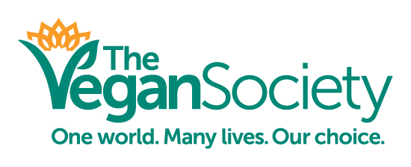

JOB TITLE: Head of Campaigns and Policy

ACCOUNTABLE TO: CEO

RESPONSIBLE FOR: Senior Advocacy & Policy Officer
Dietitian
Campaigns Officer
Research Officer

LOCATION: The Jewellery Quarter, Birmingham, UK

HOURS: 37.5 hours per week

SALARY: £25,000 - £27,000 depending on experience

Are you passionate about changing the way we treat animals? Do you want to help save our environment? Do you want to improve public health by promoting amazing plant-based food?

Our new Head of Campaigns and Policy will lead and manage our campaigns team, engaging with individuals, groups and the government in order to provide vegan solutions to many of the problems our society currently faces. You will engage with political audiences and public institutions to meet the Society’s campaigning objectives (food, environment, rights of humans and other animals, education and health). You will build credibility and relationships with Parliamentarians and work in collaboration with organisations with similar goals.

We are looking for a passionate, highly motivated individual who can significantly expand our campaigns and help raise our public profile.

The successful candidate will have excellent communication and networking skills backed up with experience in public policy, as well as being fully committed to the values of The Vegan Society. You will be able to demonstrate experience of leading a team, setting objectives and ensuring those targets are achieved, on time and on budget.

Working at The Vegan Society is a very rewarding experience. As well as offering a fully supportive team of likeminded individuals to work alongside, we also offer:

- A solution-focused atmosphere and hard working environment
- Flexible working hours, with the possibility of some remote working
- Employee Assistance Programme and health cash-back scheme
- Cycle-to-work scheme
- Childcare vouchers scheme
- Animal companion compassionate leave
- 28 Days leave and 8 Bank Holidays
- Office location in the Jewellery Quarter of Birmingham
The application deadline is 17:00 Friday 22nd August 2016.
Please send your completed application form to ceo@vegansociety.com.

